
Sleep stage classification using EEG (Advanced)

December 13, 2025
Helwan university
FCAIH Medical Informatics

Presented by:
-Menna Osama 20228020
-Amira Kamel 20228004
-Omnia Saeed 20228003
Directed by : Dr.Eman Sawires

- Abstract:
This project aims to develop an automated system for classifying sleep stages using electroencephalography (EEG) signals.
A Sleep-EDF Cassette dataset containing full-night recordings of 20 healthy individuals was used, along with multi-channel PSG signals and expert tags (hypnograms). Advanced signal processing steps, including filtering, time and frequency domain feature extraction, and wavelet transform, were applied.
Then, four different machine learning models(Random forest , SVM, Decision Tree , Logistic Regression) were trained on five files from dataset Only and evaluated . The Random Forest model showed the best performance with an accuracy of 96.29% , but this model (Random Forest) has achieved an accuracy of 92 % when it trained on Twenty files from dataset.

- Introduction :
- EEG Signal Overview :
EEG (Electroencephalography):Technique to record electrical activity of the brain. Measures voltage fluctuations between electrodes on the scalp. Signals are typically sampled at 100–256 Hz.
Why EEG for Sleep ? Sleep architecture is defined by distinct, cyclical patterns in brain wave activity. Each sleep stage has a unique "fingerprint" that can be identified in the EEG signal.

EEG Brain Waves:
    - Delta & Theta dominate during sleep; Alpha & Beta more during wakefulness.
    - Wave amplitude decreases as frequency increases (Delta: high amplitude, Gamma: low amplitude).
    - Delta waves: high amplitude (~75 µV) slow waves, dominant in N3.
    - Sleep Sages : Wake , N1 , N2 , N3 , REM => Wake , NREM , REM

Sleep spindles in N2 stage:
The term sleep spindles refers to a specific pattern of brain waves that occurs during sleep. Sleep spindles are identified by electroencephalography (EEG), which measures electrical activity in the brain.
Sleep spindles are an indicator of NREM sleep. When sleep spindles appear on an EEG readout, that shows a person has fallen asleep. Sleep spindles may be present in all stages of NREM, but they are most prevalent in stage 2 NREM sleep
K-complexes: sharp waves in N2 stage :
A K-complex is a waveform that may be seen on an electroencephalogram(EEG). It occurs during stage 2 NREM sleep . It is the "largest event in healthy human EEG".^{[1]} They are more frequent in the first sleep cycles.

- The Medical problem:
- Current Gold Standard: Manual scoring by a sleep technologist.
  - They visually inspect 30-second epochs of EEG, EOG, and EMG data.
  - For an 8-hour sleep study, this means reviewing 960 epochs.
- Drawbacks:
  - Time-consuming: Takes 1-2 hours per study.
  - Subjective: Prone to inter-scorer and intra-scorer variability.
  - Not Scalable: Creates a bottleneck in sleep clinics.

- The Importance of Our Project :
- Efficiency & Scalability: Provide a rapid, automated preliminary analysis, freeing up experts for more complex tasks.
- Objective Standardization: Reduce human bias and variability in scoring.
- Importance : Helps detect sleep disorders (insomnia, Narcolepsy sleep apnea). Faster and cheaper than manual scoring. Useful for clinicians and sleep research.

- Dataset Description :
Dataset Name:
Sleep-EDF Cassette Dataset (SC) – Kaggle Release
Source:
Distributed on Kaggle (mirrored from PhysioNet Sleep-EDF “Cassette Study”).
Content:
Around 20 healthy subjects
Total of 38–40 full-night sleep recordings
305 files in total in the Kaggle dataset structure

- Methodology:
The steps of processing the data are presented in Diagram. The procedure starts with filtering and segmenting the EEG signals into 30 seconds epochs using 0.5-45 Hz Band-Pass filter & 49 Notch filter. Frequency domain , Time domain & Wavelet features are extracted from each epoch, and then each epoch is classified into WAKE, N1 , N2 ,N3 and REM stages using our five models.

Apply filters
Band-pass: 0.5 - 45 Hz , Notch: 49 Hz

Select best EEG channel

Read EDF file
mne.io.read_raw_edf()

Balancing data (Smote)
Split into 30s epochs

Extract Features
Calibrate EEG Signal

Sleep Stage Output
Classification with 5 models

- Data Acquisition:
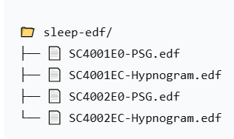
Initially, we match the PSG files with the Hypnogram files using a function find_matching_hypnogram(psg_file_path) via ID (ex:SC4001)

We used 5 files once, 21 files once (like the paper format), and all the data once.
The sleep recordings include several channels, but we used
a single EEG best channel (Mostly Fpz-Cz). The recordings were sampled at 100
Hz sampling rate. The true classes of sleep stage for the used dataset
were manually classified into one of the five stages (W, N1,N2, N3, REM) by
sleep experts and were included in a separate synchronized hypnogram file.
- Preprocessing:
A typical sleep stage classification system consists of three main
phases: pre-processing, feature extraction, and classification. Initially,
the best EEG channel is filtered using an FIR bandpass filter
(0.5 – 45 Hz) & IIR notch filter(49 HZ). The data was then segmented into 30-seconds
epochs.
- Feature Extraction:
Feature extraction was performed on each of the resulting windows
and yielded several features per window.
->Time domain features : Mean , RMS , Std , Variance , Energy , Range , Skewness , Kurtosis , ZCR , Entropy
->Frequency domain features : Delta power , Theta power , Alpha power , Beta power , Gamma power , : Delta ratio , Theta ratio , Alpha ratio , Beta ratio , Gamma ratio
->Wavelet features
"The extracted features from the EEG signals were initially divided into training (80%) and testing (20%) sets using stratified splitting to maintain the original class distribution. To address the significant class imbalance observed in the training data—particularly the underrepresentation of N1 and N3 stages—Synthetic Minority Over-sampling Technique (SMOTE) was applied exclusively to the training set after feature extraction. This approach generated synthetic samples for minority classes while preserving the authenticity of the testing set for realistic performance evaluation.
The balanced training features were then used to train five machine learning models to categorize sleep stages. Finally, all models were evaluated on the original, unaltered testing set (20% of data) to assess their classification performance and generalization capability."

- Evaluation and Analysis:
- Performance metrics used:
Accuracy: Percentage of correct classifications
Precision: Accuracy of positive classification
Recall: Ability to retrieve positive cases
F1-Score: Average harmonic between Precision and Recall
Confusion Matrix: Error analysis
Cross-Validation: Assessment of generalization
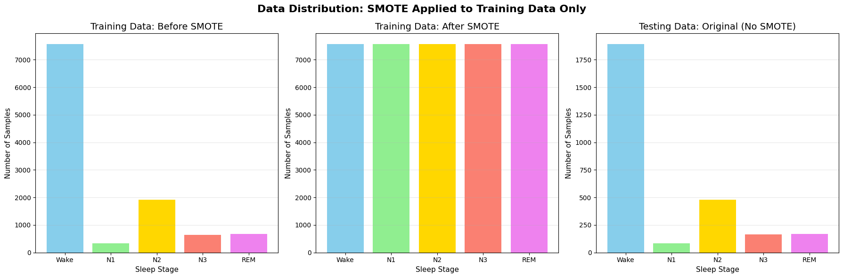
- When using 5 files :
✅ Total epochs processed: 13933
📊 Total Label Distribution:
- Wake: 9469 epochs (68.0%)
- N1: 412 epochs (3.0%)
- N2: 2390 epochs (17.2%)
- N3: 813 epochs (5.8%)
- REM: 849 epochs (6.1%)
📊 Data split information BEFORE SMOTE:
- Training data (original): 11146 samples
- Testing data (original): 2787 samples
📊 Data distribution in training set BEFORE SMOTE:
- Wake: 7575 samples (68.0%)
- N1: 330 samples (3.0%)
- N2: 1912 samples (17.2%)
- N3: 650 samples (5.8%)
- REM: 679 samples (6.1%)
📊 Data distribution AFTER SMOTE (Training data only):
- Wake: 7575 samples (20.0%)
- N1: 7575 samples (20.0%)
- N2: 7575 samples (20.0%)
- N3: 7575 samples (20.0%)
- REM: 7575 samples (20.0%)

📊 Testing data (NOT balanced with SMOTE):
- Wake: 1894 samples (68.0%)
- N1: 82 samples (2.9%)
- N2: 478 samples (17.2%)
- N3: 163 samples (5.8%)
- REM: 170 samples (6.1%)

Model | Accuracy (%) | F1_Score(Weighted) | F1_Score(Macro)
Random Forest | 93.43% | 93.90% | 81.37%
Logistic Regression | 89.31% | 90.36% | 75.54%
KNN | 88.41% | 89.49% | 72.67%
Decision Tree | 89.99% | 91.09% | 75.99%

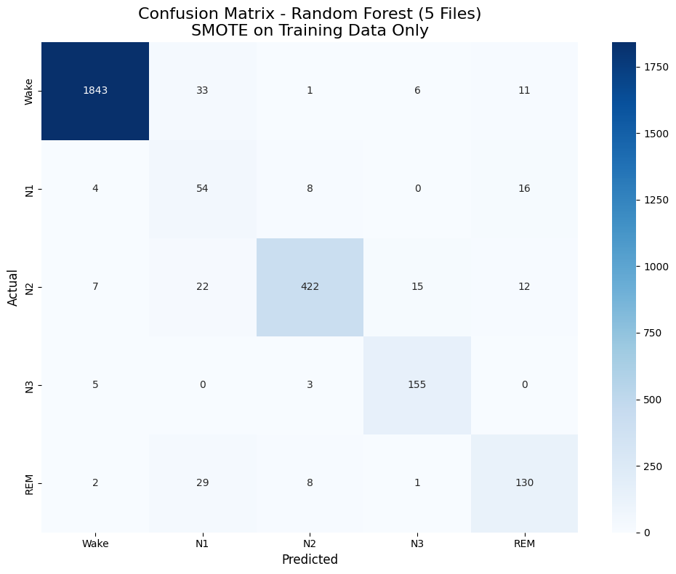
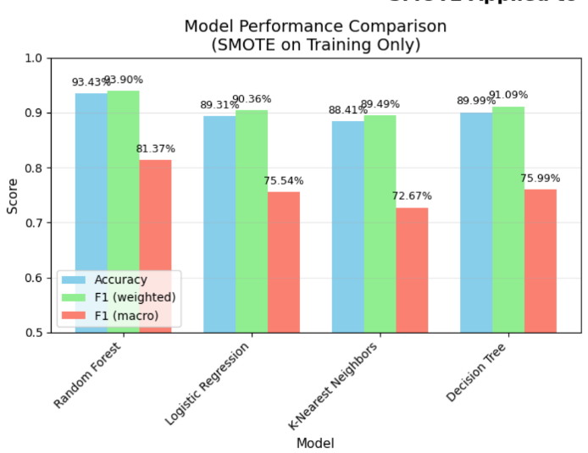

- When using 21 files :
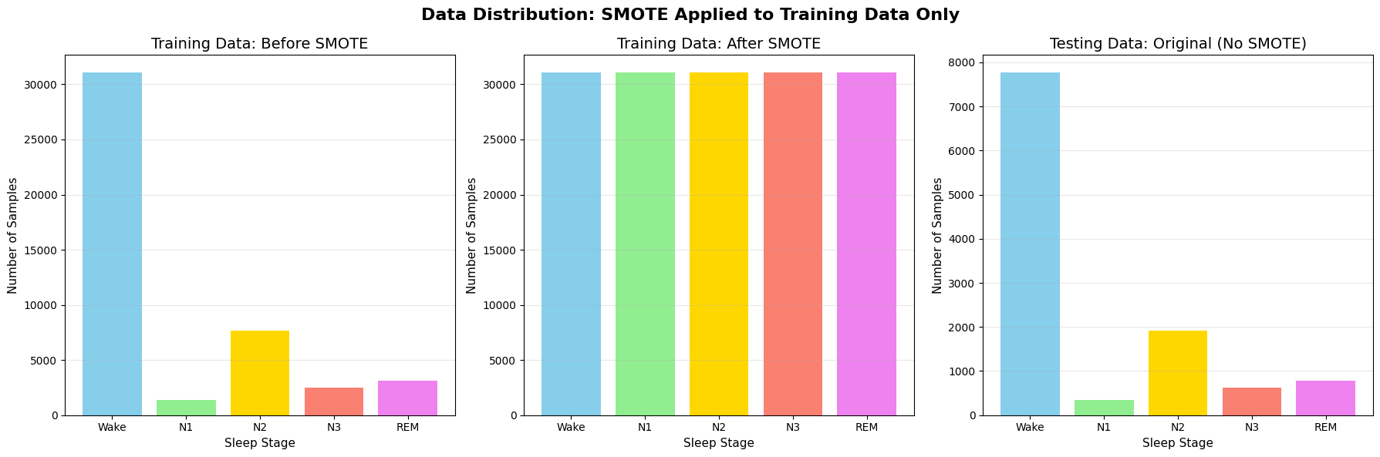

✅ Total epochs processed: 57217
📊 Total Label Distribution:
- Wake: 38885 epochs (68.0%)
- N1: 1754 epochs (3.1%)
- N2: 9598 epochs (16.8%)
- N3: 3080 epochs (5.4%)
- REM: 3900 epochs (6.8%)
📊 Data split information BEFORE SMOTE:
- Training data (original): 45773 samples
- Testing data (original): 11444 samples
📊 Data distribution in training set BEFORE SMOTE:
- Wake: 31108 samples (68.0%)
- N1: 1403 samples (3.1%)
- N2: 7678 samples (16.8%)
- N3: 2464 samples (5.4%)
- REM: 3120 samples (6.8%)
📊 Data distribution AFTER SMOTE (Training data only):
- Wake: 31108 samples (20.0%)
- N1: 31108 samples (20.0%)
- N2: 31108 samples (20.0%)
- N3: 31108 samples (20.0%)
- REM: 31108 samples (20.0%)
📊 Testing data (NOT balanced with SMOTE):
- Wake: 7777 samples (68.0%)
- N1: 351 samples (3.1%)
- N2: 1920 samples (16.8%)
- N3: 616 samples (5.4%)
- REM: 780 samples (6.8%)

Model | Accuracy (%) | F1_Score(Weighted) | F1_Score(Macro)
Random Forest | 91.56% | 92.06% | 77.69%
Logistic Regression | 87.54% | 88.78% | 71.01%
KNN | 87.05% | 88.01% | 70.13%
Decision Tree | 87.11% | 88.55% | 71.36%

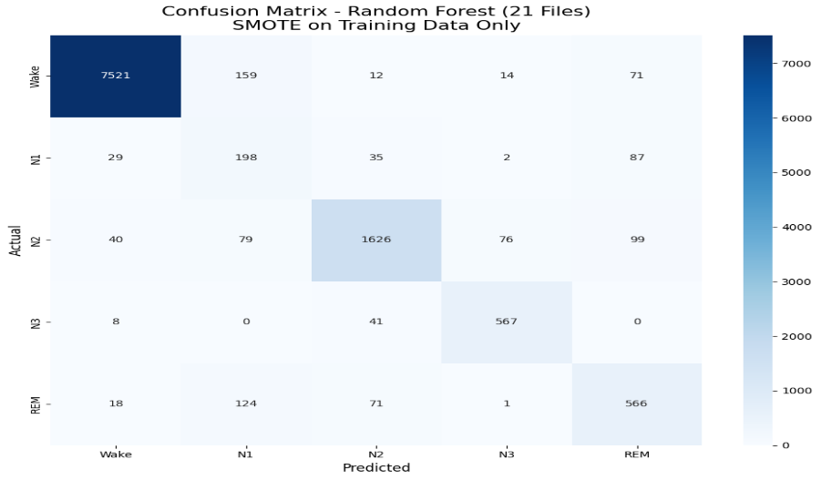
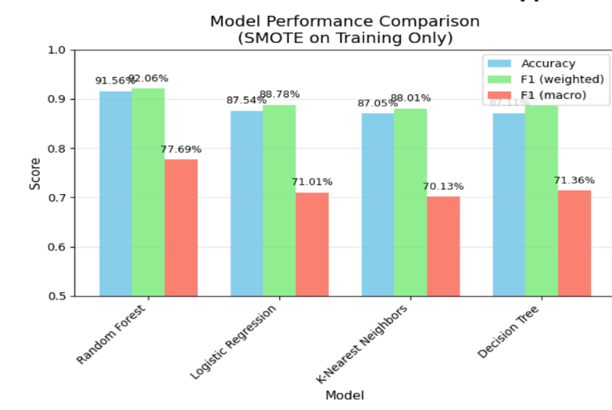
- When using 152 files :
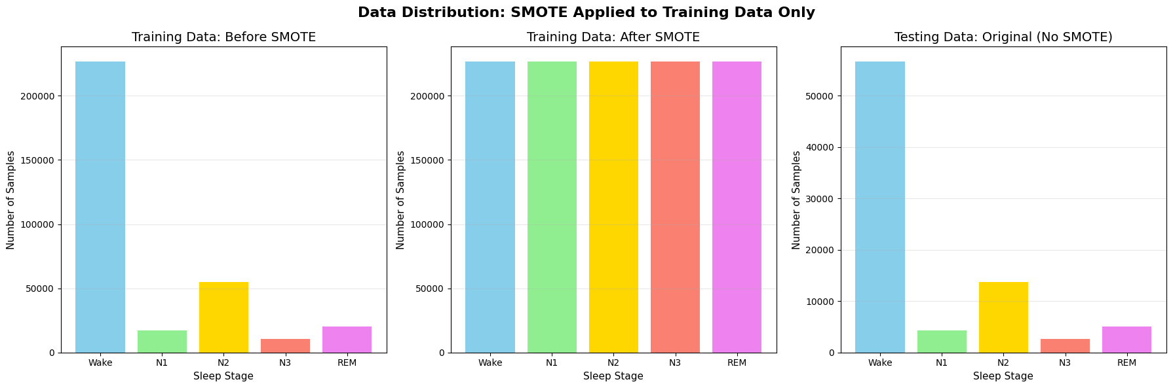
✅ Total epochs processed: 412081
📊 Total Label Distribution:
- Wake: 283654 epochs (68.8%)
- N1: 21223 epochs (5.2%)
- N2: 68661 epochs (16.7%)
- N3: 12944 epochs (3.1%)
- REM: 25599 epochs (6.2%)
📊 Data split information BEFORE SMOTE:
- Training data (original): 329664 samples
- Testing data (original): 82417 samples
📊 Data distribution in training set BEFORE SMOTE:
- Wake: 226923 samples (68.8%)
- N1: 16978 samples (5.2%)
- N2: 54929 samples (16.7%)
- N3: 10355 samples (3.1%)
- REM: 20479 samples (6.2%)
📊 Data distribution AFTER SMOTE (Training data only):
- Wake: 226923 samples (20.0%)
- N1: 226923 samples (20.0%)
- N2: 226923 samples (20.0%)
- N3: 226923 samples (20.0%)
- REM: 226923 samples (20.0%)
📊 Testing data (NOT balanced with SMOTE):
- Wake: 56731 samples (68.8%)
- N1: 4245 samples (5.2%)
- N2: 13732 samples (16.7%)
- N3: 2589 samples (3.1%)
- REM: 5120 samples (6.2%)

Model | Accuracy (%) | F1_Score(Weighted) | F1_Score(Macro)
Random Forest | 84.35% | 85.86% | 67.88%
Logistic Regression | 79.89% | 82.29% | 61.37%
KNN | 80.35% | 82.15% | 59.83%
Decision Tree | 79.23% | 81.90% | 61.54%

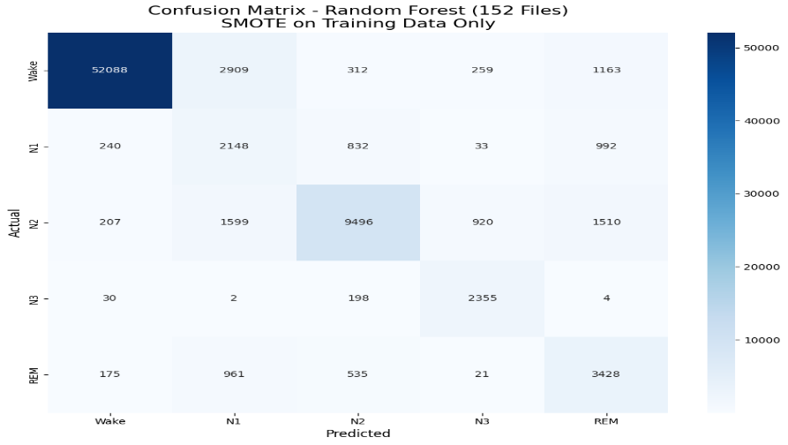
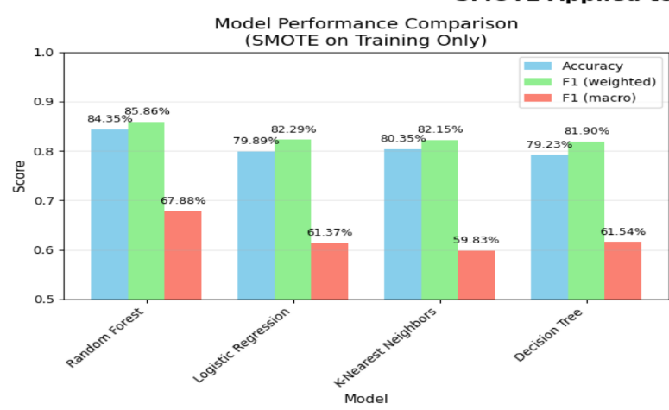

- Papers:
- https://www.mdpi.com/1099-4300/18/9/272
1-The Same dataset
2-Sampling frequency = 100 HZ
3-EEG Channel = only the EEG Fpz-Cz signal .
4-Epoche = 10 sec
5- number of files = 39
6-number of epochs = 23,806 EEG epochs of 39 PSG recordings (No Smote)
7-Almost the same feature extraction
8-Models : KNN , Decision Tree
9-six-state sleep stages: wake, Stage 1, Stage 2, Stage 3, Stage 4 and REM
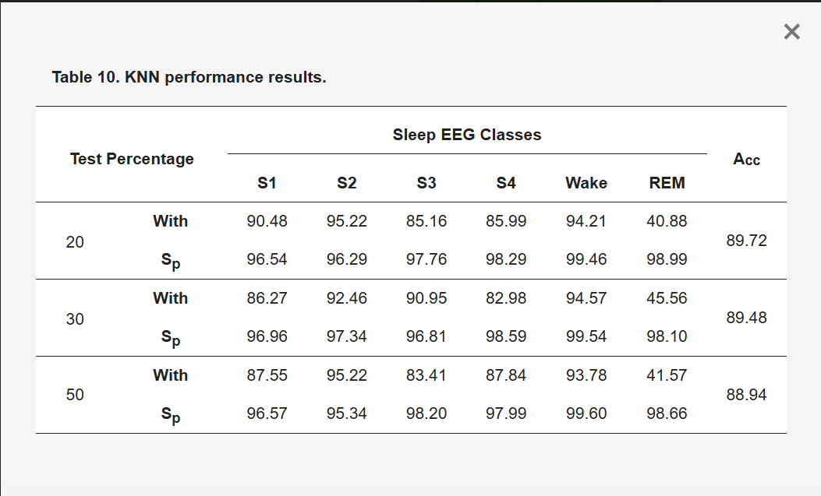
10-Randomly divide the data set into training set (80 %) and test set (20 %).
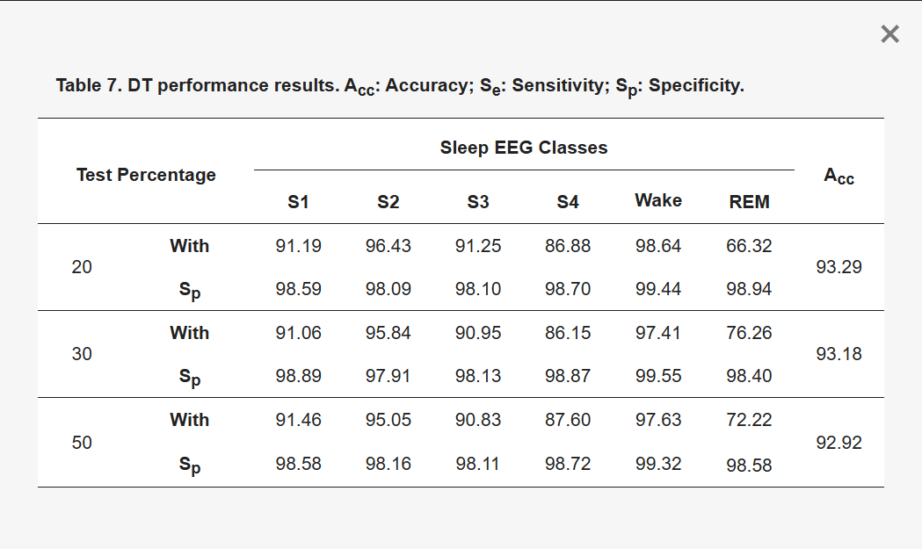

- https://www.researchgate.net/publication/257602130_Metric_learning_for_automatic_sleep_stage_classification
1-The Same dataset
3-Sampling frequency = 100 HZ
4- number of files = 4 recordings: sc4002e0,sc4012e0, sc4102e0, and sc4112e0
5-Almost the same feature extraction
6-Models : KNN
7-Randomly divide the data set into training set (70 %) and test set (30 %)
8-sleep stages:
=> Awake, Stage1 + REM, Stage 2 and Slow Wave Stage (SWS) : 30-second Epoches of Fpz-Oz channel.

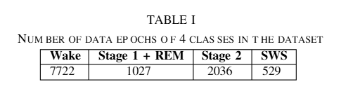
- Accuracy = 94.49
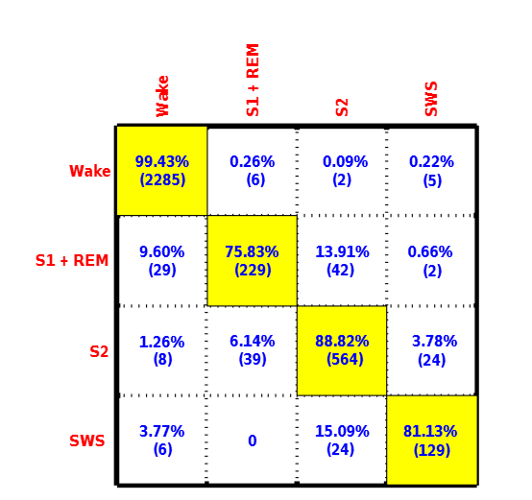

=> Awake/sleep classiﬁcation : 30-second Epoches of Pz-Oz channel
Number of data epochs of “Awake” and “Sleep”
classes are 7722 and 3592 respectively
- Accuracy = 98.32 %

- https://www.researchgate.net/publication/361851218_Sleep_Stage_Classification_Using_Random_Forest_Method
1-The Same dataset
2-Sampling frequency = 100 HZ
3-EEG Channel = EEG Fpz-Cz channel .
4-Epoche = 30 sec
5- number of files = 21 sleep recordings(No Smote)
8-Different feature extraction
9-Models : Random Forest
10-Three sleep stages: WAKE, REM, and NREM stage
11-Randomly divide the data set into training set (90 %) and test set (10 %).

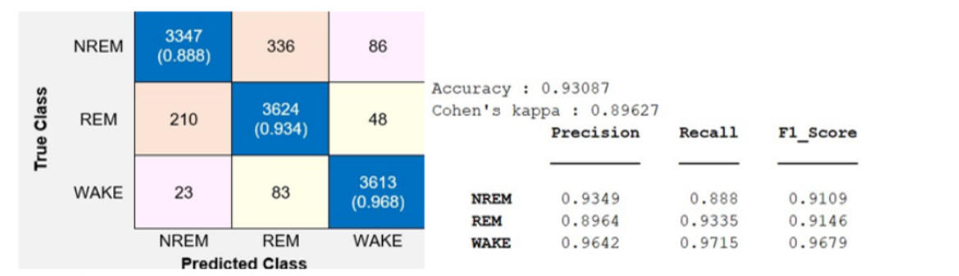

- Reference:
- https://www.sleepfoundation.org/how-sleep-works/sleep-spindles
- https://en.wikipedia.org/wiki/K-complex
- https://www.researchgate.net/publication/257602130_Metric_learning_for_automatic_sleep_stage_classification
- https://www.researchgate.net/publication/361851218_Sleep_Stage_Classification_Using_Random_Forest_Method
- Dataset: https://www.kaggle.com/datasets/iamommpatel/physiobank-database-sleep-edfx-cassette
- Notebook : https://colab.research.google.com/drive/1ZA2IVggkQPu4nOGvDlGTfrac-otJcyXl?usp=sharing
- Rangayyan, Rangaraj M. Biomedical Signal Analysis Wiley (2015)

